Rajesh R S

Rajesh R S brings more than 16 years of rich experience across corporate, training, and career counselling domains. His professional journey spans working closely with diverse teams, young professionals, and students, giving him a deep understanding of workplace expectations, skill gaps, and the real challenges individuals face while planning their careers.
With strong corporate exposure, Rajesh has firsthand insight into industry standards, employer expectations, performance culture, and evolving job market trends. This background enables him to offer practical, realistic, and relevant guidance rather than generic advice. Over the years, he has successfully transitioned this experience into training and counselling, where he has designed and delivered employability skills programmes, communication and personality development sessions, and career guidance workshops for school and college students.
Rajesh has trained and mentored thousands of learners across educational institutions and corporate training platforms. His work has helped individuals improve self-confidence, career clarity, interview readiness, and professional behaviour. Many of those guided by him have gone on to make informed academic choices, secure better job opportunities, and adapt successfully to professional environments.
As a career coach, Rajesh believes that every individual has unique strengths and potential. His counselling approach is empathetic, structured, and goal-oriented, focusing on helping individuals understand themselves, explore suitable career paths, and build the skills required to succeed.
Above all, Rajesh is deeply committed to creating transformation, not just career outcomes. He believes that when individuals gain clarity, confidence, and purpose, success naturally follows. His mission is to help every learner recognise their true potential, make informed choices, and move forward with courage—one confident step at a time.

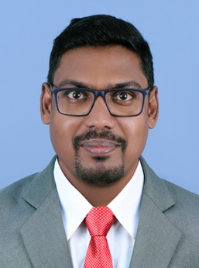

Vidhya Conceicoe

A results-driven Career Counselor and Soft Skills Trainer with a strong passion for guiding students and professionals toward informed career decisions and workplace success. Experienced in career assessment, goal setting, resume building, interview preparation, and employability skill development. Skilled at delivering engaging training sessions on communication skills, confidence building, leadership, teamwork, time management, and professional etiquette. Adept at understanding individual strengths, aligning them with market trends, and creating personalized career roadmaps. Known for a supportive mentoring approach, practical insights, and interactive training methodologies that drive measurable improvement. Has successfully worked with students, job seekers, and early-career professionals to enhance self-awareness, clarity, and readiness for competitive corporate environments. Committed to lifelong learning and empowering individuals to unlock their potential, improve employability, and achieve sustainable career growth in today’s dynamic job market.



Haritha Nair
Haritha Nair is a Corporate Trainer and Career Counselor with Yellow Ladder, dedicated to helping people build meaningful, future-ready careers. She has facilitated numerous programs for colleges and corporates, specializing in communication skills, interview readiness, leadership, and personal effectiveness. Drawing on experience across classroom, virtual, and outbound learning formats, Haritha designs engaging sessions that translate concepts into practical habits participants can apply immediately.

As a Career Counselor, she supports students and working professionals in clarifying goals, identifying strengths, and creating action plans that align with their aspirations. Her empathetic style, structured guidance, and evidence-based tools make difficult decisions easier and more confident.

Haritha has collaborated with institutions on industry-academia initiatives and has guided hundreds of learners through career transitions. At Yellow Ladder, she continues to champion growth, resilience, and lifelong learning—helping every individual move one step higher on the ladder toward purpose and success in work and life every day.



Jiju K

A strategic and results-driven Learning and Development professional with over two decades of experience in the Banking and Financial Services Industry, complemented by extensive expertise in career counselling and student development. Specializes in designing and delivering high-impact training programs that enhance performance across all management levels. Proven success across training, sales, and capability development, having conducted 500+ workshops nationwide for professionals and students alike. Adept at mentoring individuals on career planning, employability skills, leadership readiness, and personal effectiveness. A certified Train the Trainer and digital learning expert, recognized for aligning learning interventions with business goals while empowering learners to achieve sustainable growth.

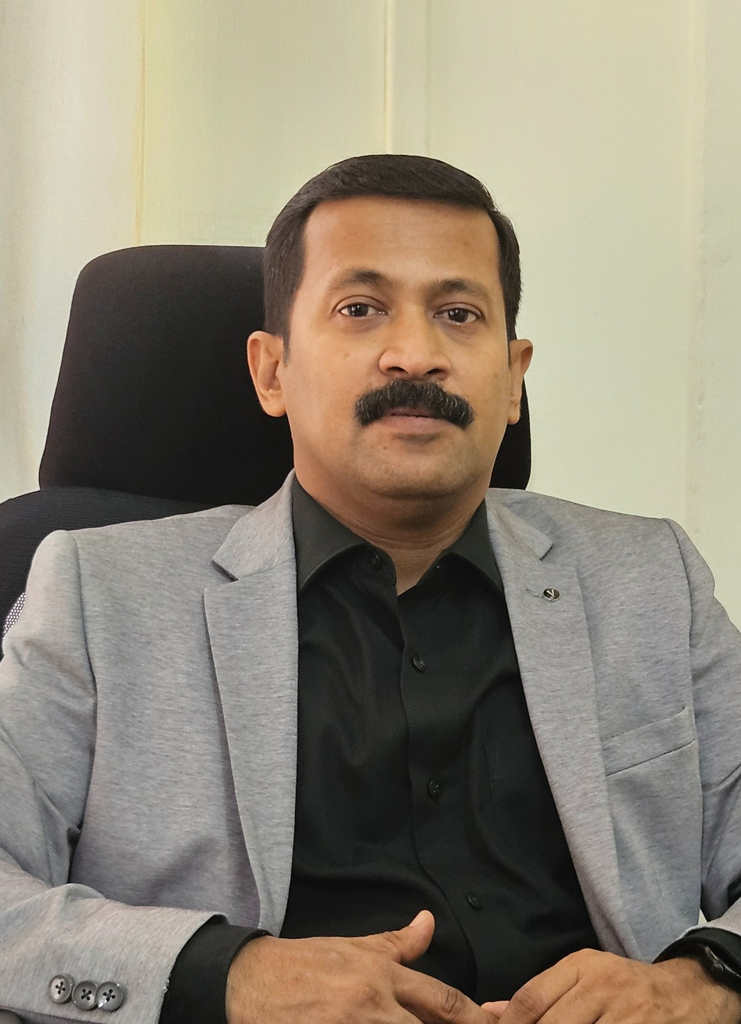

Aswin Chandran C
A seasoned learning and development professional with over 7.5 years of experience delivering high-impact training programs to students, graduates, and working professionals. The trainer specializes in bridging the gap between academics and industry through structured Campus to Corporate transition programs. Core expertise includes Soft Skills Enhancement, Employability Aptitude, Design Thinking, and Advanced Data Analytics. Training sessions are practical, engaging, and outcome-focused, designed to meet industry expectations and learner needs. With a strong emphasis on real-world applications, interactive methodologies, and case-based learning, the trainer helps participants build confidence, sharpen problem-solving skills, and enhance overall job readiness. The approach focuses on measurable outcomes, long-term skill development, and professional excellence.

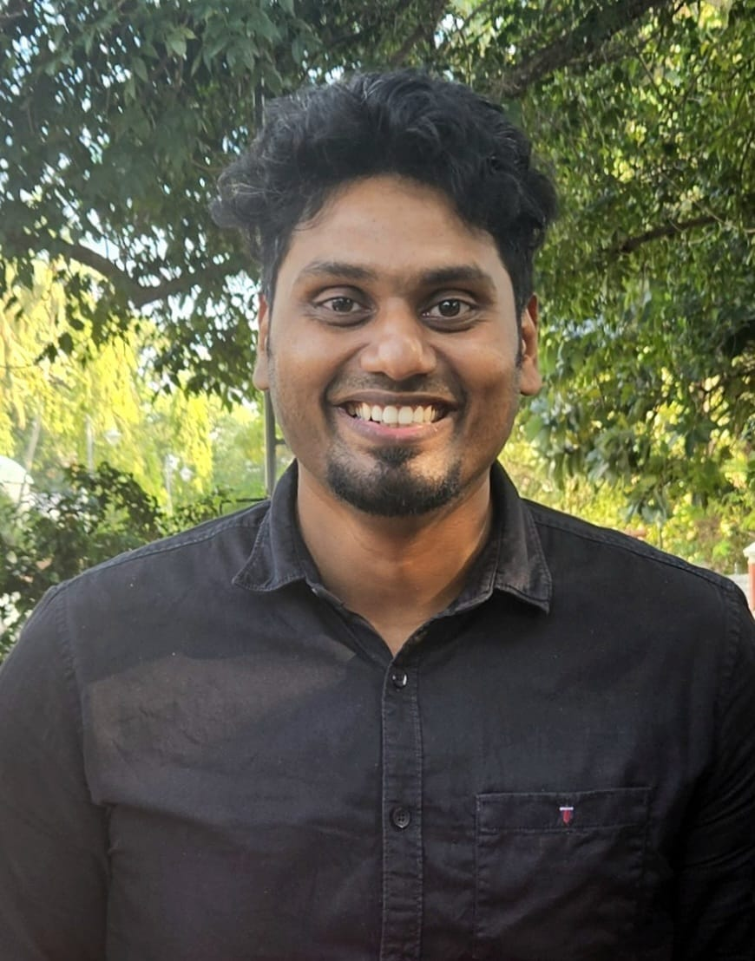

Resmi R Chandran
Resmi R Chandran is an Employability Skills Trainer and practicing Career Counsellor with over three years of experience delivering youth-focused skilling and career guidance programs aligned with CSR and government-led initiatives.
She has extensive experience in conducting employability skills training alongside individual and group career counselling, supporting students in making informed academic and career decisions.
Her core expertise includes communication skills, workplace readiness, interview preparation, professional behaviour, student mentoring, and structured documentation and reporting.
With a learner-centric and outcome-oriented approach, she works closely with first-generation and underserved learners, enabling them to build confidence, career clarity, and sustainable employability.
